Tab 1

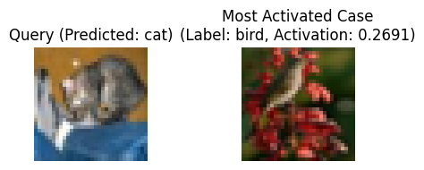

Query 1:

True Class: cat

Predicted Class: cat

Most Activated Case Label: bird

Most Activated Activation: 0.2691

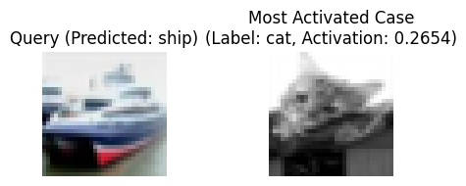

Query 2:

True Class: ship

Predicted Class: ship

Most Activated Case Label: cat

Most Activated Activation: 0.2654

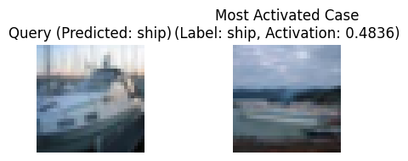

Query 3:

True Class: ship

Predicted Class: ship

Most Activated Case Label: ship

Most Activated Activation: 0.4836

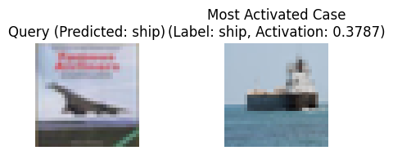

Query 4:

True Class: airplane

Predicted Class: ship

Most Activated Case Label: ship

Most Activated Activation: 0.3787

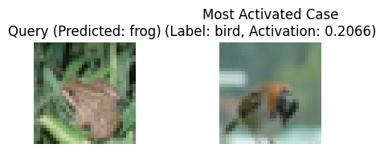

Query 5:

True Class: frog

Predicted Class: frog

Most Activated Case Label: bird

Most Activated Activation: 0.2066

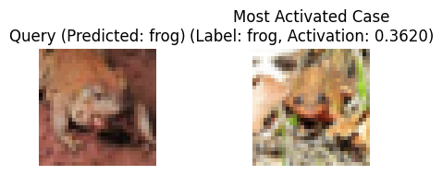

Query 6:

True Class: frog

Predicted Class: frog

Most Activated Case Label: frog

Most Activated Activation: 0.3620

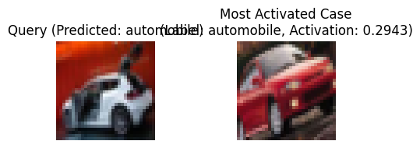

Query 7:

True Class: automobile

Predicted Class: automobile

Most Activated Case Label: automobile

Most Activated Activation: 0.2943

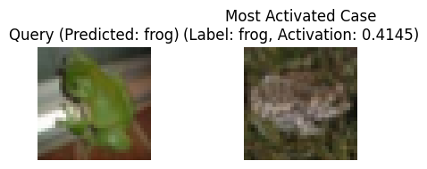

Query 8:

True Class: frog

Predicted Class: frog

Most Activated Case Label: frog

Most Activated Activation: 0.4145

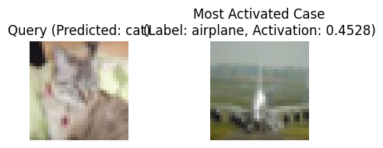

Query 9:

True Class: cat

Predicted Class: cat

Most Activated Case Label: airplane

Most Activated Activation: 0.4528

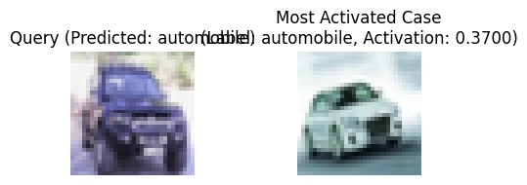

Query 10:

True Class: automobile

Predicted Class: automobile

Most Activated Case Label: automobile

Most Activated Activation: 0.3700

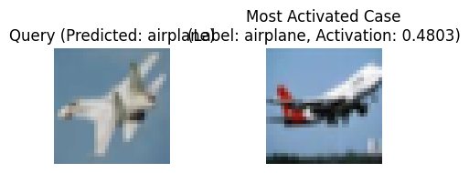

Query 11:

True Class: airplane

Predicted Class: airplane

Most Activated Case Label: airplane

Most Activated Activation: 0.4803

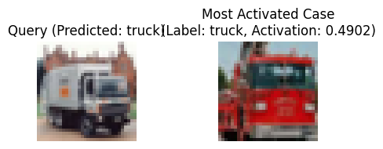

Query 12:

True Class: truck

Predicted Class: truck

Most Activated Case Label: truck

Most Activated Activation: 0.4902

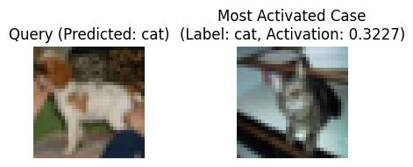

Query 13:

True Class: dog

Predicted Class: cat

Most Activated Case Label: cat

Most Activated Activation: 0.3227

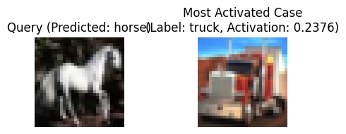

Query 14:

True Class: horse

Predicted Class: horse

Most Activated Case Label: truck

Most Activated Activation: 0.2376

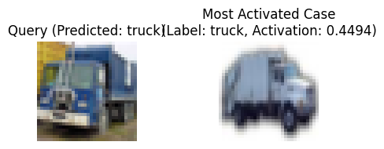

Query 15:

True Class: truck

Predicted Class: truck

Most Activated Case Label: truck

Most Activated Activation: 0.4494

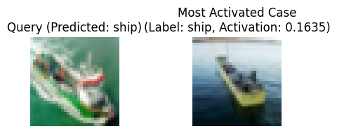

Query 16:

True Class: ship

Predicted Class: ship

Most Activated Case Label: ship

Most Activated Activation: 0.1635

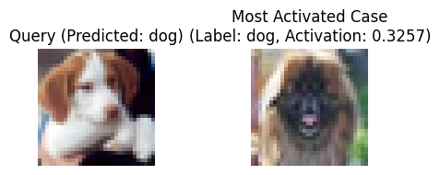

Query 17:

True Class: dog

Predicted Class: dog

Most Activated Case Label: dog

Most Activated Activation: 0.3257

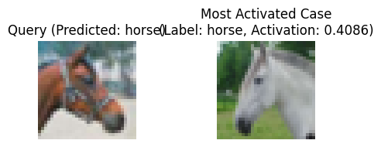

Query 18:

True Class: horse

Predicted Class: horse

Most Activated Case Label: horse

Most Activated Activation: 0.4086

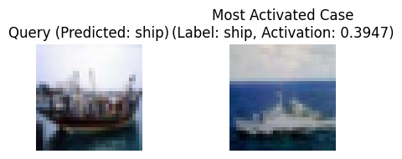

Query 19:

True Class: ship

Predicted Class: ship

Most Activated Case Label: ship

Most Activated Activation: 0.3947

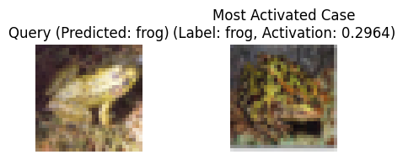

Query 20:

True Class: frog

Predicted Class: frog

Most Activated Case Label: frog

Most Activated Activation: 0.2964

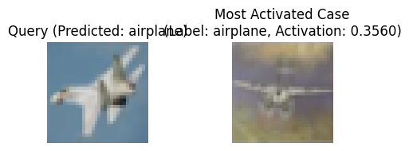

Query 11:

True Class: airplane

Predicted Class: airplane

Most Activated Case Label: airplane

Most Activated Activation: 0.3560

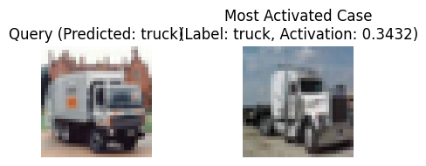

Query 12:

True Class: truck

Predicted Class: truck

Most Activated Case Label: truck

Most Activated Activation: 0.3432

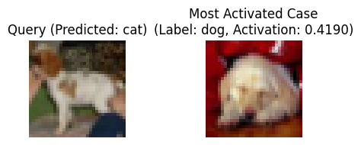

Query 13:

True Class: dog

Predicted Class: cat

Most Activated Case Label: dog

Most Activated Activation: 0.4190

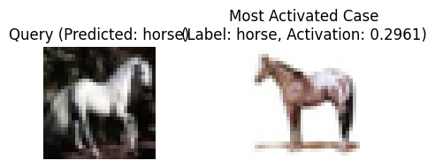

Query 14:

True Class: horse

Predicted Class: horse

Most Activated Case Label: horse

Most Activated Activation: 0.2961

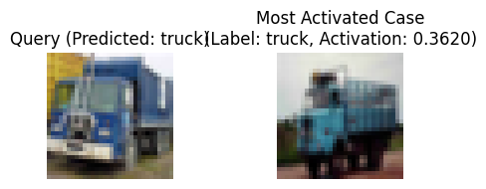

Query 15:

True Class: truck

Predicted Class: truck

Most Activated Case Label: truck

Most Activated Activation: 0.3620

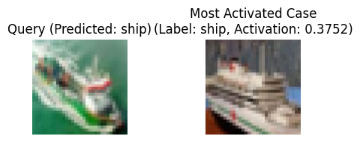

Query 16:

True Class: ship

Predicted Class: ship

Most Activated Case Label: ship

Most Activated Activation: 0.3752

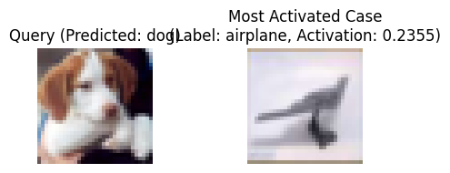

Query 17:

True Class: dog

Predicted Class: dog

Most Activated Case Label: airplane

Most Activated Activation: 0.2355

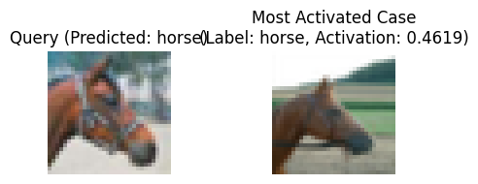

Query 18:

True Class: horse

Predicted Class: horse

Most Activated Case Label: horse

Most Activated Activation: 0.4619

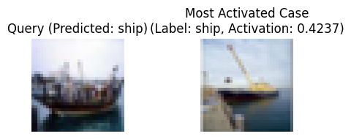

Query 19:

True Class: ship

Predicted Class: ship

Most Activated Case Label: ship

Most Activated Activation: 0.4237

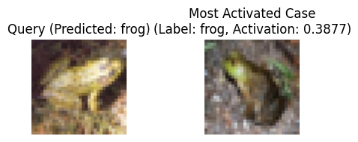

Query 20:

True Class: frog

Predicted Class: frog

Most Activated Case Label: frog

Most Activated Activation: 0.3877

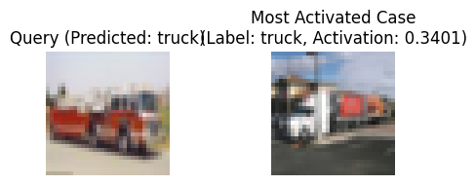

Query 8001:

True Class: truck

Predicted Class: truck

Most Activated Case Label: truck

Most Activated Activation: 0.3401

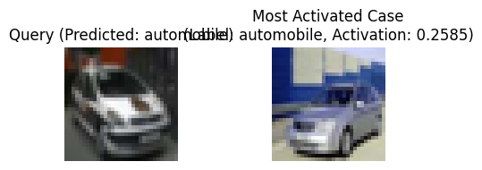

Query 8002:

True Class: automobile

Predicted Class: automobile

Most Activated Case Label: automobile

Most Activated Activation: 0.2585

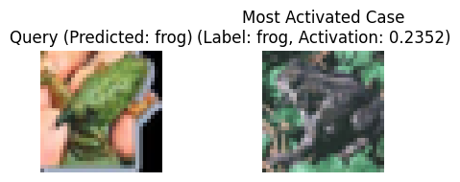

Query 8003:

True Class: frog

Predicted Class: frog

Most Activated Case Label: frog

Most Activated Activation: 0.2352

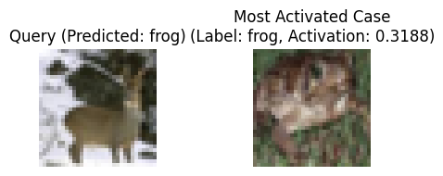

Query 8004:

True Class: deer

Predicted Class: frog

Most Activated Case Label: frog

Most Activated Activation: 0.3188

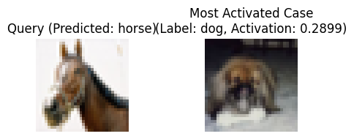

Query 8005:

True Class: horse

Predicted Class: horse

Most Activated Case Label: dog

Most Activated Activation: 0.2899

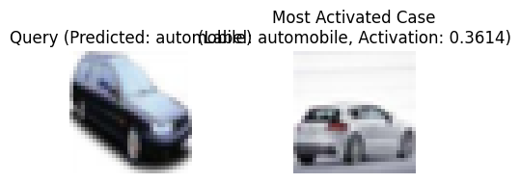

Query 8006:

True Class: automobile

Predicted Class: automobile

Most Activated Case Label: automobile

Most Activated Activation: 0.3614

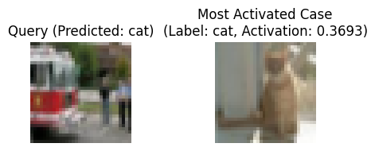

Query 8007:

True Class: truck

Predicted Class: cat

Most Activated Case Label: cat

Most Activated Activation: 0.3693



Query 8008:

True Class: airplane

Predicted Class: frog

Most Activated Case Label: deer

Most Activated Activation: 0.1679

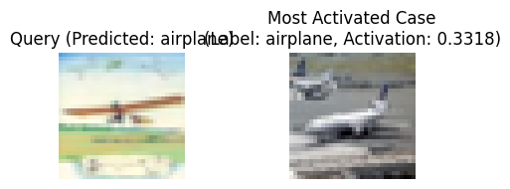

Query 8009:

True Class: airplane

Predicted Class: airplane

Most Activated Case Label: airplane

Most Activated Activation: 0.3318

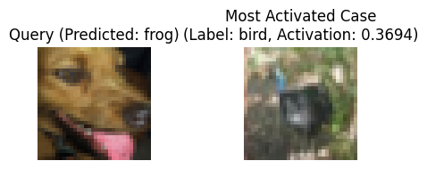

Query 8010:

True Class: dog

Predicted Class: frog

Most Activated Case Label: bird

Most Activated Activation: 0.3694

results to show

**Correct Predictions**





**Correct Prediction but Most Activated Case is Wrong**





**Mis-classification**





results 1/16/2025

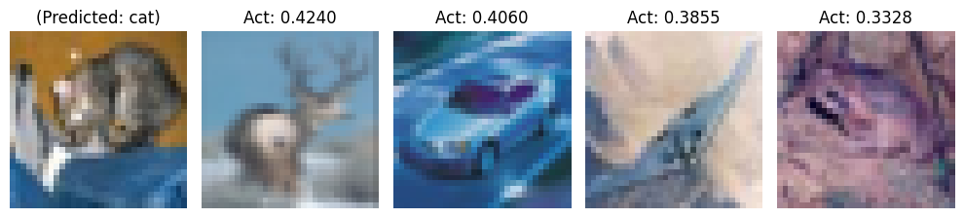

Top 3 Classes: cat (5.7316), dog (4.8675), frog (4.4472)

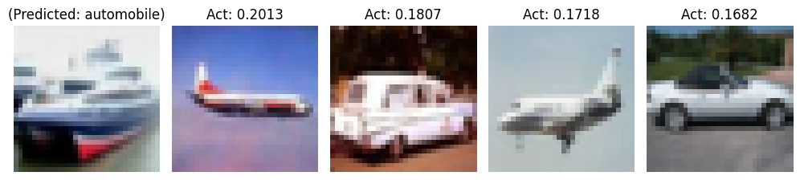

Top 3 Classes: automobile (3.2945), airplane (2.6865), ship (2.5443)

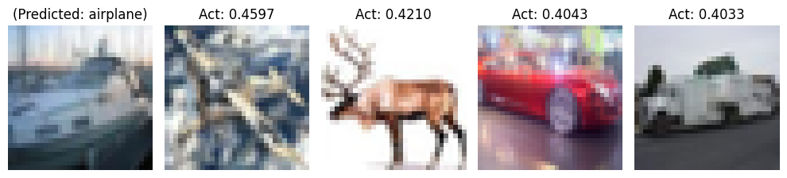

Top 3 Classes: airplane (10.2598), truck (9.0202), ship (7.8461)

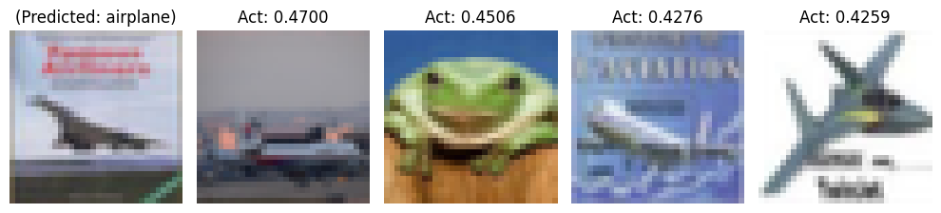

Top Classes: airplane (9.4300), ship (5.4787), automobile (5.1161)

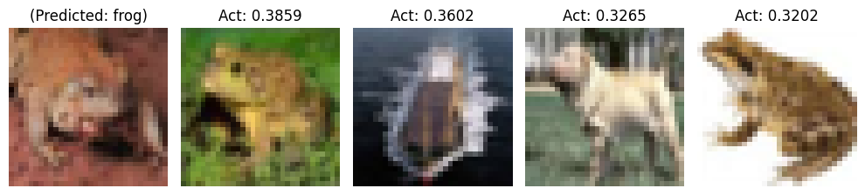

Top 3 Classes: frog (7.8938), deer (4.3032), dog (3.9011)

Top 3 Activations: 7.8938, 4.3032, 3.9011

Case 1:

Label: frog

Activation: 0.3859

Case 2:

Label: ship

Activation: 0.3602

Case 3:

Label: dog

Activation: 0.3265

Case 4:

Label: frog

Activation: 0.3202

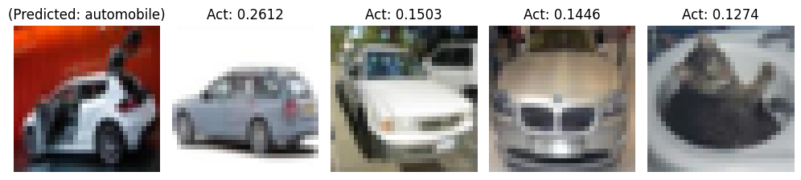

--- Query 7 ---

True Class: automobile

Predicted Class: automobile

Top 3 Classes: automobile, cat, dog

Top 3 Activations: 2.3816, 1.7513, 1.2627

Case 1:

Label: automobile

Activation: 0.2612

Case 2:

Label: automobile

Activation: 0.1503

Case 3:

Label: automobile

Activation: 0.1446

Case 4:

Label: cat

Activation: 0.1274

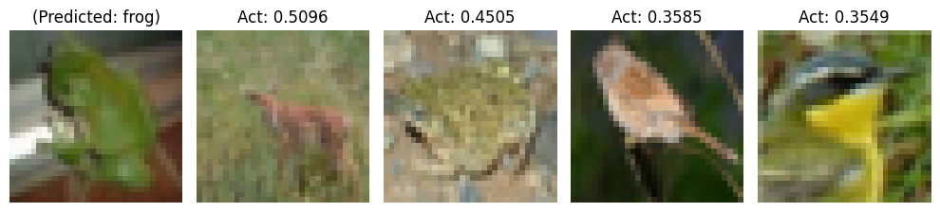

--- Query 8 ---

True Class: frog

Predicted Class: frog

Top 3 Classes: frog, deer, bird

Top 3 Activations: 6.8967, 6.5686, 6.4494

Case 1:

Label: deer

Activation: 0.5096

Case 2:

Label: frog

Activation: 0.4505

Case 3:

Label: bird

Activation: 0.3585

Case 4:

Label: bird

Activation: 0.3549

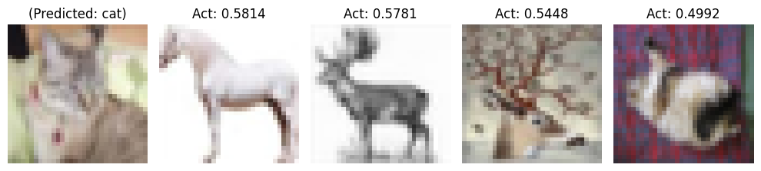

--- Query 9 ---

True Class: cat

Predicted Class: cat

Top 3 Classes: cat, dog, deer

Top 3 Activations: 10.1691, 9.4865, 9.1740

Case 1:

Label: horse

Activation: 0.5814

Case 2:

Label: deer

Activation: 0.5781

Case 3:

Label: deer

Activation: 0.5448

Case 4:

Label: cat

Activation: 0.4992

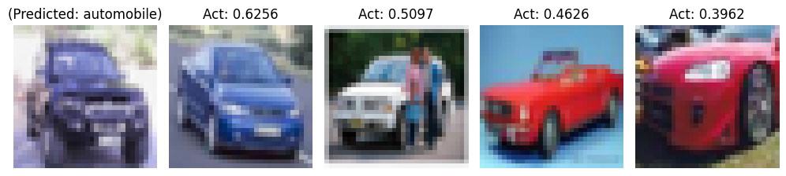

--- Query 10 ---

True Class: automobile

Predicted Class: automobile

Top 3 Classes: automobile, truck, ship

Top 3 Activations: 10.2318, 5.5759, 3.7436

Case 1:

Label: automobile

Activation: 0.6256

Case 2:

Label: automobile

Activation: 0.5097

Case 3:

Label: automobile

Activation: 0.4626

Case 4:

Label: automobile

Activation: 0.3962

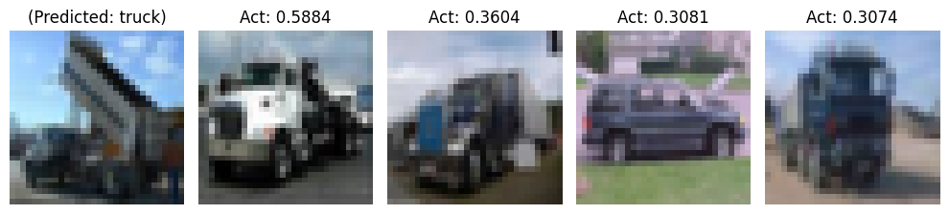

--- Query 51 ---

True Class: truck

Predicted Class: truck

Top 3 Classes: truck, automobile, airplane

Top 3 Activations: 5.9380, 4.6051, 4.5238

Case 1:

Label: truck

Activation: 0.5884

Case 2:

Label: truck

Activation: 0.3604

Case 3:

Label: automobile

Activation: 0.3081

Case 4:

Label: truck

Activation: 0.3074

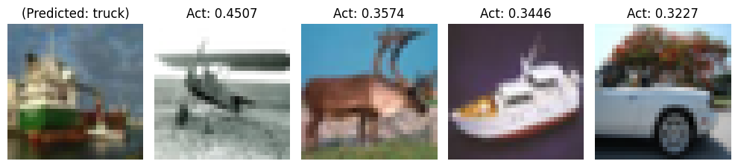

--- Query 52 ---

True Class: ship

Predicted Class: truck

Top 3 Classes: truck, ship, deer

Top 3 Activations: 6.2083, 6.0682, 5.6050

Case 1:

Label: airplane

Activation: 0.4507

Case 2:

Label: deer

Activation: 0.3574

Case 3:

Label: ship

Activation: 0.3446

Case 4:

Label: automobile

Activation: 0.3227

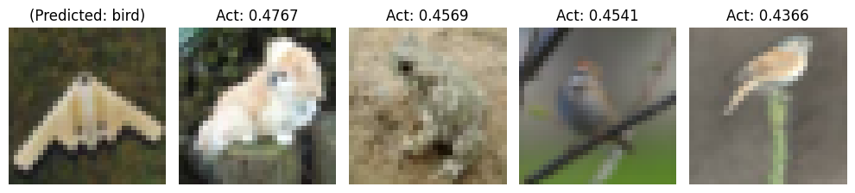

--- Query 53 ---

True Class: airplane

Predicted Class: bird

Top 3 Classes: bird, dog, frog

Top 3 Activations: 7.6789, 6.6253, 6.0948

Case 1:

Label: dog

Activation: 0.4767

Case 2:

Label: frog

Activation: 0.4569

Case 3:

Label: bird

Activation: 0.4541

Case 4:

Label: bird

Activation: 0.4366

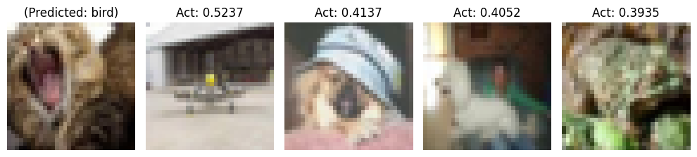

--- Query 54 ---

True Class: cat

Predicted Class: bird

Top 3 Classes: bird, cat, frog

Top 3 Activations: 7.3834, 7.1461, 6.6513

Case 1:

Label: airplane

Activation: 0.5237

Case 2:

Label: dog

Activation: 0.4137

Case 3:

Label: dog

Activation: 0.4052

Case 4:

Label: frog

Activation: 0.3935

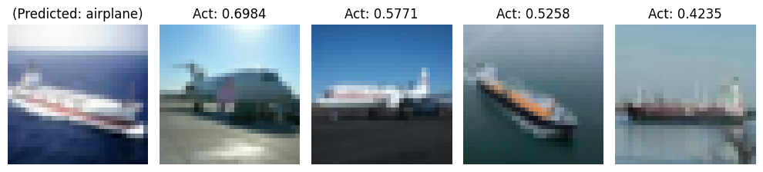

--- Query 55 ---

True Class: ship

Predicted Class: airplane

Top 3 Classes: airplane, ship, truck

Top 3 Activations: 8.3800, 7.0220, 3.2896

Case 1:

Label: airplane

Activation: 0.6984

Case 2:

Label: airplane

Activation: 0.5771

Case 3:

Label: ship

Activation: 0.5258

Case 4:

Label: ship

Activation: 0.4235

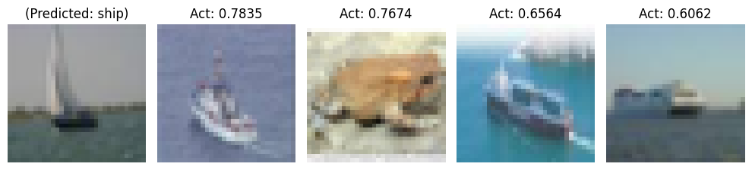

--- Query 56 ---

True Class: ship

Predicted Class: ship

Top 3 Classes: ship, airplane, deer

Top 3 Activations: 13.3723, 11.7269, 7.6291

Case 1:

Label: ship

Activation: 0.7835

Case 2:

Label: frog

Activation: 0.7674

Case 3:

Label: ship

Activation: 0.6564

Case 4:

Label: ship

Activation: 0.6062

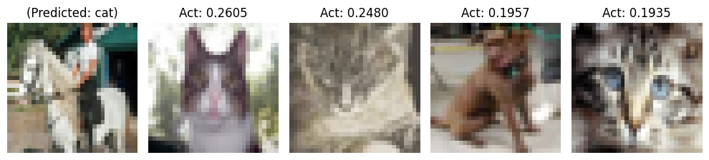

--- Query 57 ---

True Class: horse

Predicted Class: cat

Top 3 Classes: cat, dog, horse

Top 3 Activations: 4.5570, 3.9317, 3.3979

Case 1:

Label: cat

Activation: 0.2605

Case 2:

Label: cat

Activation: 0.2480

Case 3:

Label: dog

Activation: 0.1957

Case 4:

Label: cat

Activation: 0.1935



--- Query 58 ---

True Class: horse

Predicted Class: frog

Top 3 Classes: frog, cat, deer

Top 3 Activations: 3.9910, 3.7820, 3.4395

Case 1:

Label: cat

Activation: 0.3192

Case 2:

Label: deer

Activation: 0.3047

Case 3:

Label: frog

Activation: 0.2640

Case 4:

Label: ship

Activation: 0.2191



--- Query 59 ---

True Class: deer

Predicted Class: dog

Top 3 Classes: dog, bird, cat

Top 3 Activations: 8.9500, 7.8850, 7.7148

Case 1:

Label: cat

Activation: 0.5123

Case 2:

Label: bird

Activation: 0.5075

Case 3:

Label: dog

Activation: 0.4784

Case 4:

Label: horse

Activation: 0.4385

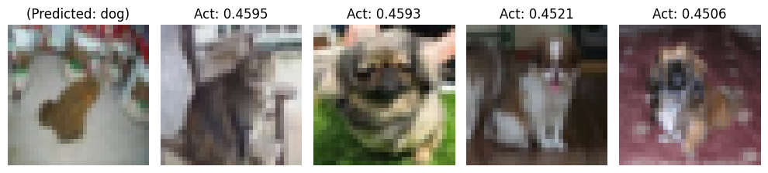

--- Query 60 ---

True Class: frog

Predicted Class: dog

Top 3 Classes: dog, deer, cat

Top 3 Activations: 8.1056, 8.0862, 6.8440

Case 1:

Label: cat

Activation: 0.4595

Case 2:

Label: dog

Activation: 0.4593

Case 3:

Label: dog

Activation: 0.4521

Case 4:

Label: dog

Activation: 0.4506

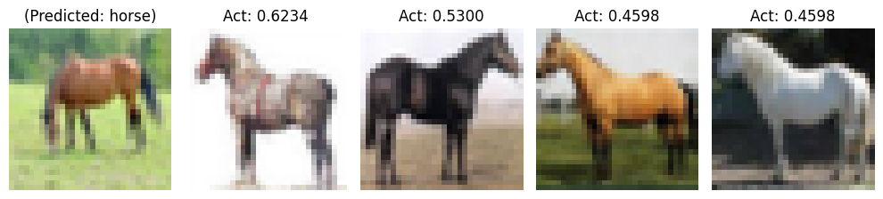

--- Query 61 ---

True Class: horse

Predicted Class: horse

Top 3 Classes: horse, deer, dog

Top 3 Activations: 10.0312, 3.9441, 3.7847

Case 1:

Label: horse

Activation: 0.6234

Case 2:

Label: horse

Activation: 0.5300

Case 3:

Label: horse

Activation: 0.4598

Case 4:

Label: horse

Activation: 0.4598

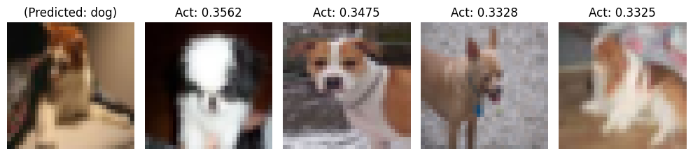

--- Query 62 ---

True Class: cat

Predicted Class: dog

Top 3 Classes: dog, cat, horse

Top 3 Activations: 6.4403, 6.2795, 4.0347

Case 1:

Label: dog

Activation: 0.3562

Case 2:

Label: dog

Activation: 0.3475

Case 3:

Label: dog

Activation: 0.3328

Case 4:

Label: dog

Activation: 0.3325

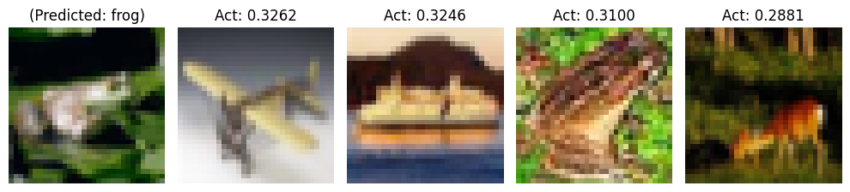

--- Query 63 ---

True Class: frog

Predicted Class: frog

Top 3 Classes: frog, deer, cat

Top 3 Activations: 6.3194, 4.5602, 4.4429

Case 1:

Label: airplane

Activation: 0.3262

Case 2:

Label: ship

Activation: 0.3246

Case 3:

Label: frog

Activation: 0.3100

Case 4:

Label: deer

Activation: 0.2881

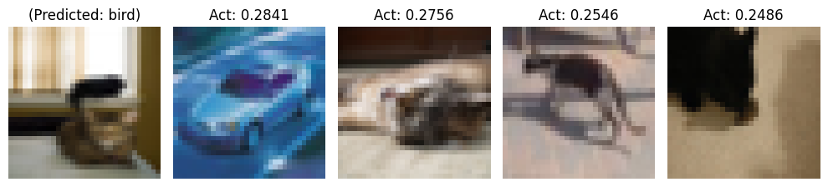

--- Query 64 ---

True Class: cat

Predicted Class: bird

Top 3 Classes: bird, airplane, cat

Top 3 Activations: 3.5913, 3.4943, 3.4673

Case 1:

Label: automobile

Activation: 0.2841

Case 2:

Label: cat

Activation: 0.2756

Case 3:

Label: cat

Activation: 0.2546

Case 4:

Label: cat

Activation: 0.2486

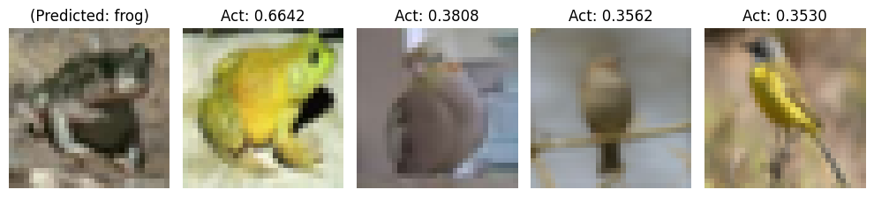

--- Query 65 ---

True Class: frog

Predicted Class: frog

Top 3 Classes: frog, cat, bird

Top 3 Activations: 8.9604, 5.9715, 5.2157

Case 1:

Label: frog

Activation: 0.6642

Case 2:

Label: bird

Activation: 0.3808

Case 3:

Label: bird

Activation: 0.3562

Case 4:

Label: bird

Activation: 0.3530



--- Query 66 ---

True Class: bird

Predicted Class: bird

Top 3 Classes: bird, frog, dog

Top 3 Activations: 5.9516, 4.4884, 3.2419

Case 1:

Label: bird

Activation: 0.5713

Case 2:

Label: bird

Activation: 0.3025

Case 3:

Label: dog

Activation: 0.2926

Case 4:

Label: bird

Activation: 0.2915

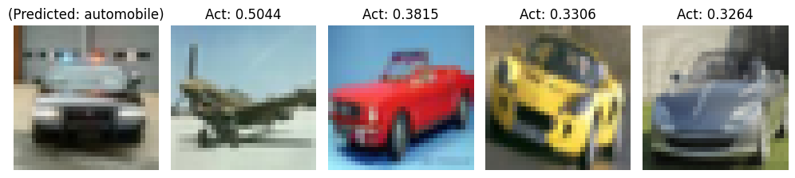

--- Query 67 ---

True Class: automobile

Predicted Class: automobile

Top 3 Classes: automobile, ship, airplane

Top 3 Activations: 5.8896, 5.2125, 4.9695

Case 1:

Label: airplane

Activation: 0.5044

Case 2:

Label: automobile

Activation: 0.3815

Case 3:

Label: automobile

Activation: 0.3306

Case 4:

Label: automobile

Activation: 0.3264

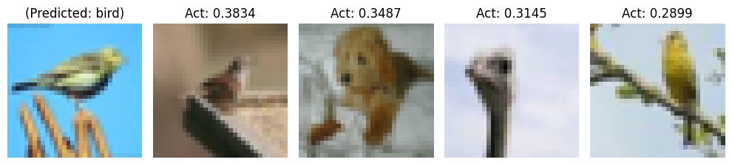

--- Query 68 ---

True Class: bird

Predicted Class: bird

Top 3 Classes: bird, dog, airplane

Top 3 Activations: 5.6681, 3.7223, 3.2185

Case 1:

Label: bird

Activation: 0.3834

Case 2:

Label: dog

Activation: 0.3487

Case 3:

Label: bird

Activation: 0.3145

Case 4:

Label: bird

Activation: 0.2899

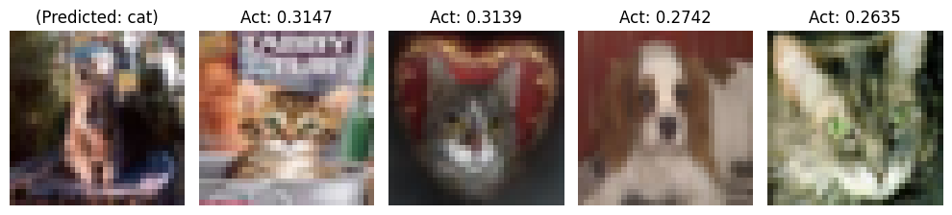

--- Query 69 ---

True Class: cat

Predicted Class: cat

Top 3 Classes: cat, dog, horse

Top 3 Activations: 4.6344, 3.5724, 3.2913

Case 1:

Label: cat

Activation: 0.3147

Case 2:

Label: cat

Activation: 0.3139

Case 3:

Label: dog

Activation: 0.2742

Case 4:

Label: cat

Activation: 0.2635

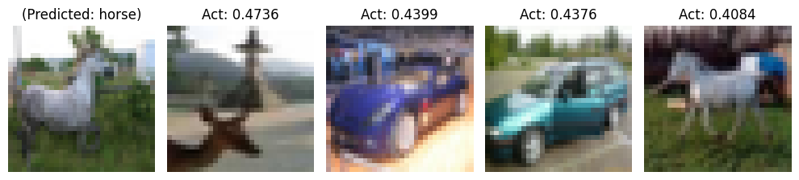

--- Query 70 ---

True Class: horse

Predicted Class: horse

Top 3 Classes: horse, truck, automobile

Top 3 Activations: 7.0247, 6.9907, 6.6876

Case 1:

Label: deer

Activation: 0.4736

Case 2:

Label: automobile

Activation: 0.4399

Case 3:

Label: automobile

Activation: 0.4376

Case 4:

Label: horse

Activation: 0.4084

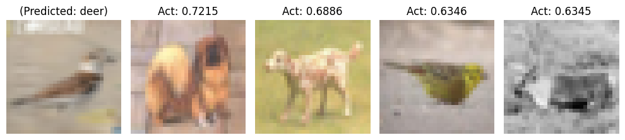

--- Query 71 ---

True Class: bird

Predicted Class: deer

Top 3 Classes: deer, cat, frog

Top 3 Activations: 11.4227, 10.6621, 10.5862

Case 1:

Label: dog

Activation: 0.7215

Case 2:

Label: dog

Activation: 0.6886

Case 3:

Label: bird

Activation: 0.6346

Case 4:

Label: deer

Activation: 0.6345

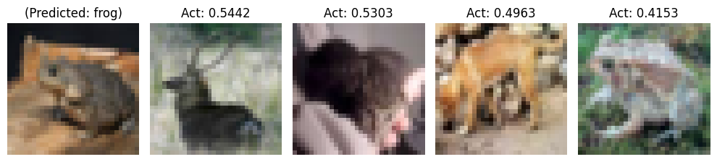

--- Query 72 ---

True Class: frog

Predicted Class: frog

Top 3 Classes: frog, dog, cat

Top 3 Activations: 8.3828, 7.0817, 6.2790

Case 1:

Label: deer

Activation: 0.5442

Case 2:

Label: cat

Activation: 0.5303

Case 3:

Label: dog

Activation: 0.4963

Case 4:

Label: frog

Activation: 0.4153

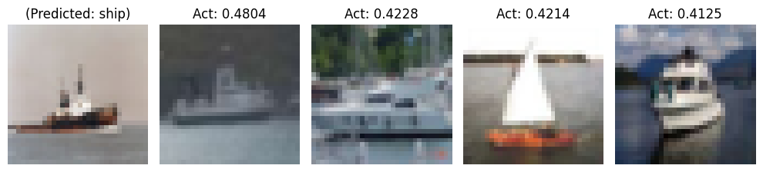

--- Query 73 ---

True Class: ship

Predicted Class: ship

Top 3 Classes: ship, dog, airplane

Top 3 Activations: 9.6095, 4.6164, 4.5441

Case 1:

Label: ship

Activation: 0.4804

Case 2:

Label: ship

Activation: 0.4228

Case 3:

Label: ship

Activation: 0.4214

Case 4:

Label: ship

Activation: 0.4125

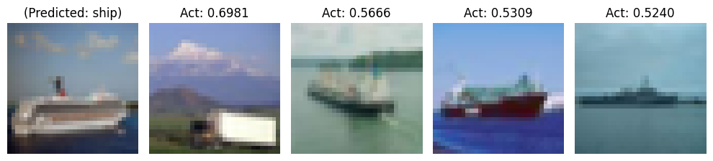

--- Query 74 ---

True Class: ship

Predicted Class: ship

Top 3 Classes: ship, airplane, truck

Top 3 Activations: 10.2444, 5.9621, 3.7061

Case 1:

Label: truck

Activation: 0.6981

Case 2:

Label: ship

Activation: 0.5666

Case 3:

Label: ship

Activation: 0.5309

Case 4:

Label: ship

Activation: 0.5240

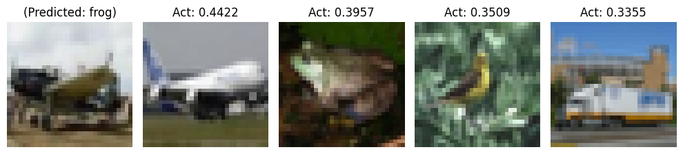

--- Query 75 ---

True Class: airplane

Predicted Class: frog

Top 3 Classes: frog, airplane, truck

Top 3 Activations: 5.5281, 4.8645, 3.8733

Case 1:

Label: airplane

Activation: 0.4422

Case 2:

Label: frog

Activation: 0.3957

Case 3:

Label: bird

Activation: 0.3509

Case 4:

Label: truck

Activation: 0.3355

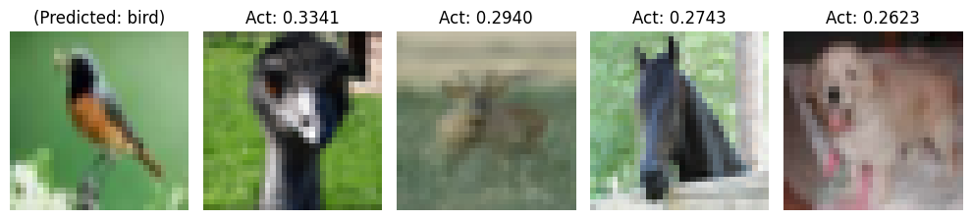

--- Query 76 ---

True Class: bird

Predicted Class: bird

Top 3 Classes: bird, deer, dog

Top 3 Activations: 3.5611, 3.0171, 2.9320

Case 1:

Label: bird

Activation: 0.3341

Case 2:

Label: deer

Activation: 0.2940

Case 3:

Label: horse

Activation: 0.2743

Case 4:

Label: dog

Activation: 0.2623

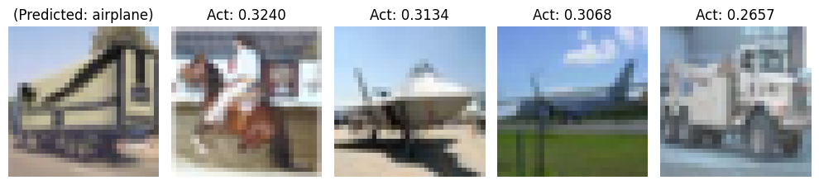

--- Query 77 ---

True Class: truck

Predicted Class: airplane

Top 3 Classes: airplane, truck, horse

Top 3 Activations: 4.8102, 4.3545, 4.2695

Case 1:

Label: horse

Activation: 0.3240

Case 2:

Label: airplane

Activation: 0.3134

Case 3:

Label: airplane

Activation: 0.3068

Case 4:

Label: truck

Activation: 0.2657

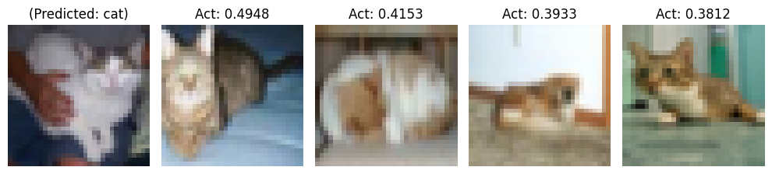

--- Query 78 ---

True Class: cat

Predicted Class: cat

Top 3 Classes: cat, frog, dog

Top 3 Activations: 8.6298, 6.8949, 5.6481

Case 1:

Label: cat

Activation: 0.4948

Case 2:

Label: cat

Activation: 0.4153

Case 3:

Label: dog

Activation: 0.3933

Case 4:

Label: cat

Activation: 0.3812

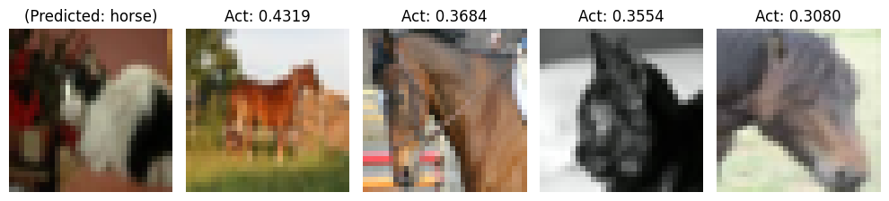

--- Query 79 ---

True Class: cat

Predicted Class: horse

Top 3 Classes: horse, cat, dog

Top 3 Activations: 6.6129, 6.5011, 6.3697

Case 1:

Label: horse

Activation: 0.4319

Case 2:

Label: horse

Activation: 0.3684

Case 3:

Label: cat

Activation: 0.3554

Case 4:

Label: horse

Activation: 0.3080

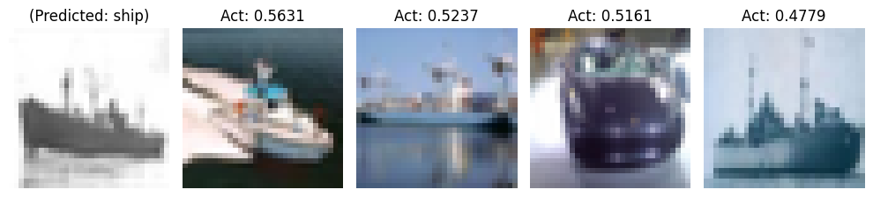

--- Query 80 ---

True Class: ship

Predicted Class: ship

Top 3 Classes: ship, airplane, automobile

Top 3 Activations: 8.8367, 7.3511, 6.1070

Case 1:

Label: ship

Activation: 0.5631

Case 2:

Label: ship

Activation: 0.5237

Case 3:

Label: automobile

Activation: 0.5161

Case 4:

Label: ship

Activation: 0.4779

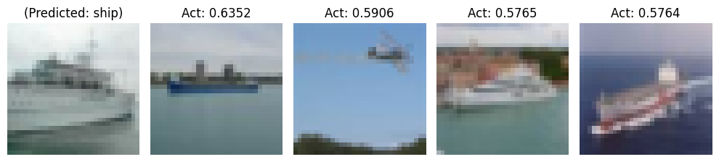

--- Query 81 ---

True Class: ship

Predicted Class: ship

Top 3 Classes: ship, airplane, automobile

Top 3 Activations: 13.9919, 8.1820, 6.6057

Case 1:

Label: ship

Activation: 0.6352

Case 2:

Label: airplane

Activation: 0.5906

Case 3:

Label: ship

Activation: 0.5765

Case 4:

Label: ship

Activation: 0.5764

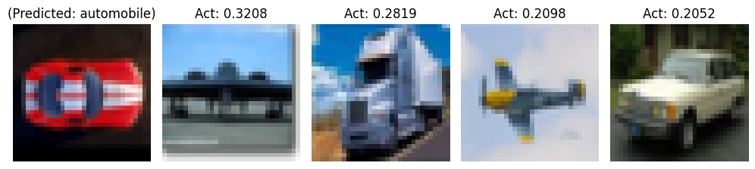

--- Query 82 ---

True Class: automobile

Predicted Class: automobile

Top 3 Classes: automobile, truck, airplane

Top 3 Activations: 3.8651, 2.5772, 2.3594

Case 1:

Label: airplane

Activation: 0.3208

Case 2:

Label: truck

Activation: 0.2819

Case 3:

Label: airplane

Activation: 0.2098

Case 4:

Label: automobile

Activation: 0.2052

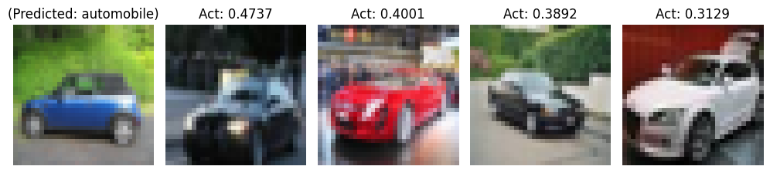

--- Query 83 ---

True Class: automobile

Predicted Class: automobile

Top 3 Classes: automobile, truck, airplane

Top 3 Activations: 7.2433, 3.4011, 3.0561

Case 1:

Label: automobile

Activation: 0.4737

Case 2:

Label: automobile

Activation: 0.4001

Case 3:

Label: automobile

Activation: 0.3892

Case 4:

Label: automobile

Activation: 0.3129

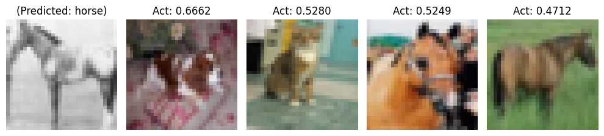

--- Query 84 ---

True Class: horse

Predicted Class: horse

Top 3 Classes: horse, cat, dog

Top 3 Activations: 10.5308, 8.6292, 8.3615

Case 1:

Label: dog

Activation: 0.6662

Case 2:

Label: cat

Activation: 0.5280

Case 3:

Label: horse

Activation: 0.5249

Case 4:

Label: horse

Activation: 0.4712

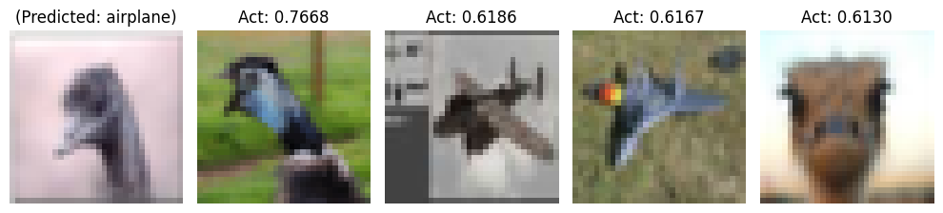

--- Query 85 ---

True Class: bird

Predicted Class: airplane

Top 3 Classes: airplane, bird, dog

Top 3 Activations: 13.9448, 13.4870, 9.5177

Case 1:

Label: bird

Activation: 0.7668

Case 2:

Label: airplane

Activation: 0.6186

Case 3:

Label: airplane

Activation: 0.6167

Case 4:

Label: bird

Activation: 0.6130

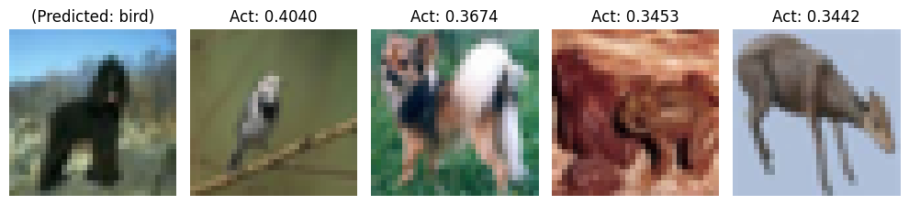

--- Query 86 ---

True Class: dog

Predicted Class: bird

Top 3 Classes: bird, deer, horse

Top 3 Activations: 6.6815, 5.9878, 5.7801

Case 1:

Label: bird

Activation: 0.4040

Case 2:

Label: dog

Activation: 0.3674

Case 3:

Label: frog

Activation: 0.3453

Case 4:

Label: deer

Activation: 0.3442

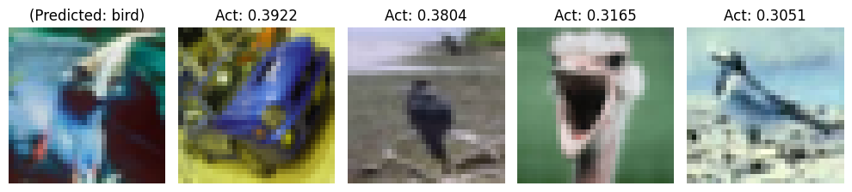

--- Query 87 ---

True Class: bird

Predicted Class: bird

Top 3 Classes: bird, deer, airplane

Top 3 Activations: 5.8515, 4.0132, 4.0063

Case 1:

Label: automobile

Activation: 0.3922

Case 2:

Label: bird

Activation: 0.3804

Case 3:

Label: bird

Activation: 0.3165

Case 4:

Label: bird

Activation: 0.3051

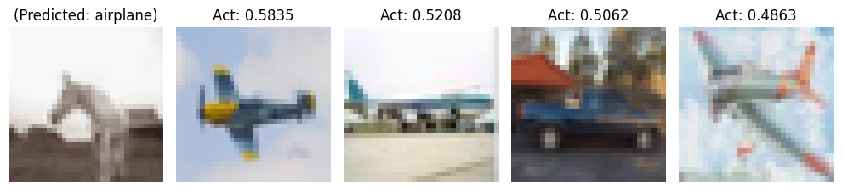

--- Query 88 ---

True Class: horse

Predicted Class: airplane

Top 3 Classes: airplane, ship, deer

Top 3 Activations: 9.4402, 8.8081, 7.2549

Case 1:

Label: airplane

Activation: 0.5835

Case 2:

Label: airplane

Activation: 0.5208

Case 3:

Label: automobile

Activation: 0.5062

Case 4:

Label: airplane

Activation: 0.4863

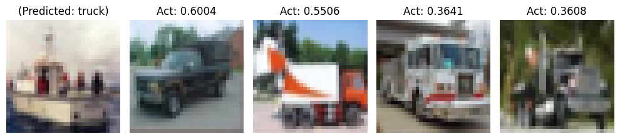

--- Query 89 ---

True Class: ship

Predicted Class: truck

Top 3 Classes: truck, ship, cat

Top 3 Activations: 7.9088, 6.4694, 3.7300

Case 1:

Label: truck

Activation: 0.6004

Case 2:

Label: truck

Activation: 0.5506

Case 3:

Label: truck

Activation: 0.3641

Case 4:

Label: truck

Activation: 0.3608

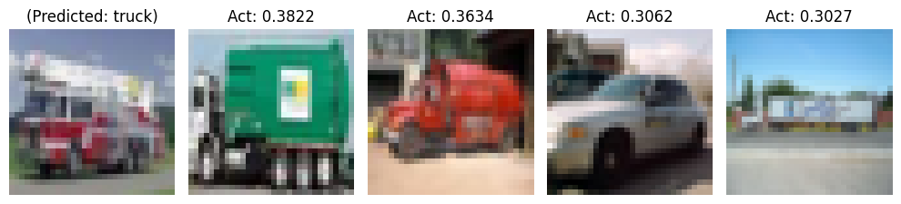

--- Query 90 ---

True Class: truck

Predicted Class: truck

Top 3 Classes: truck, automobile, airplane

Top 3 Activations: 6.6610, 4.2704, 2.7287

Case 1:

Label: truck

Activation: 0.3822

Case 2:

Label: truck

Activation: 0.3634

Case 3:

Label: automobile

Activation: 0.3062

Case 4:

Label: truck

Activation: 0.3027

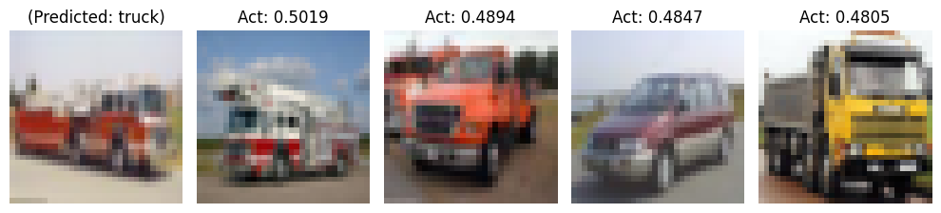

--- Query 8001 ---

True Class: truck

Predicted Class: truck

Top 3 Classes: truck, automobile, airplane

Top 3 Activations: 10.9729, 4.6527, 3.7972

Case 1:

Label: truck

Activation: 0.5019

Case 2:

Label: truck

Activation: 0.4894

Case 3:

Label: automobile

Activation: 0.4847

Case 4:

Label: truck

Activation: 0.4805

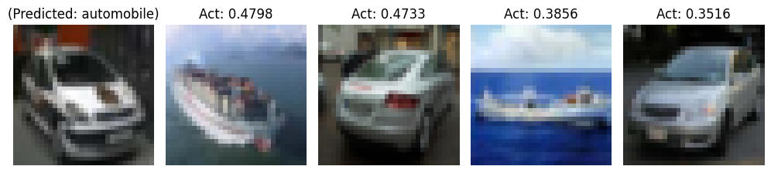

--- Query 8002 ---

True Class: automobile

Predicted Class: automobile

Top 3 Classes: automobile, ship, truck

Top 3 Activations: 6.3626, 5.9754, 4.9910

Case 1:

Label: ship

Activation: 0.4798

Case 2:

Label: automobile

Activation: 0.4733

Case 3:

Label: ship

Activation: 0.3856

Case 4:

Label: automobile

Activation: 0.3516

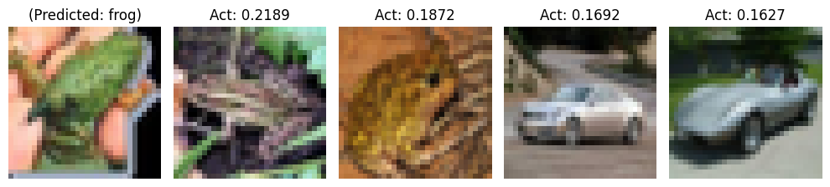

--- Query 8003 ---

True Class: frog

Predicted Class: frog

Top 3 Classes: frog, automobile, cat

Top 3 Activations: 2.7930, 1.9514, 1.7057

Case 1:

Label: frog

Activation: 0.2189

Case 2:

Label: frog

Activation: 0.1872

Case 3:

Label: automobile

Activation: 0.1692

Case 4:

Label: automobile

Activation: 0.1627

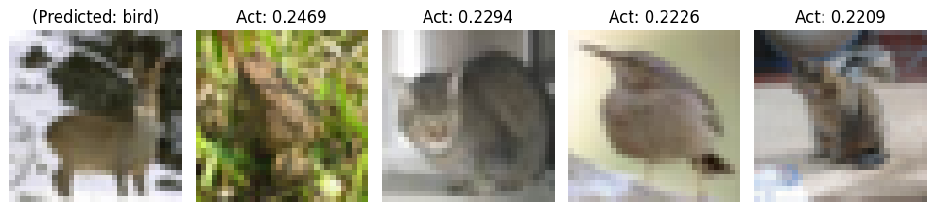

--- Query 8004 ---

True Class: deer

Predicted Class: bird

Top 3 Classes: bird, frog, deer

Top 3 Activations: 3.8879, 3.4674, 3.4597

Case 1:

Label: frog

Activation: 0.2469

Case 2:

Label: cat

Activation: 0.2294

Case 3:

Label: bird

Activation: 0.2226

Case 4:

Label: cat

Activation: 0.2209

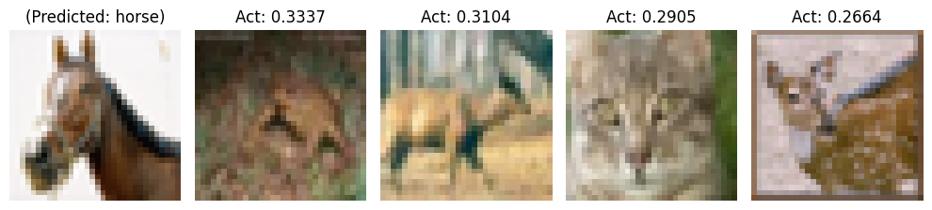

--- Query 8005 ---

True Class: horse

Predicted Class: horse

Top 3 Classes: horse, deer, bird

Top 3 Activations: 5.1531, 4.4324, 3.5669

Case 1:

Label: frog

Activation: 0.3337

Case 2:

Label: deer

Activation: 0.3104

Case 3:

Label: cat

Activation: 0.2905

Case 4:

Label: deer

Activation: 0.2664

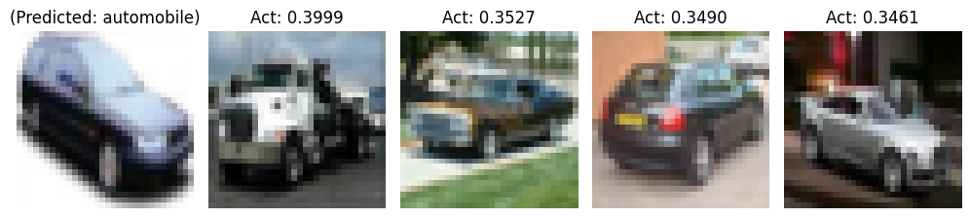

--- Query 8006 ---

True Class: automobile

Predicted Class: automobile

Top 3 Classes: automobile, truck, airplane

Top 3 Activations: 8.1482, 5.1552, 4.2721

Case 1:

Label: truck

Activation: 0.3999

Case 2:

Label: automobile

Activation: 0.3527

Case 3:

Label: automobile

Activation: 0.3490

Case 4:

Label: automobile

Activation: 0.3461

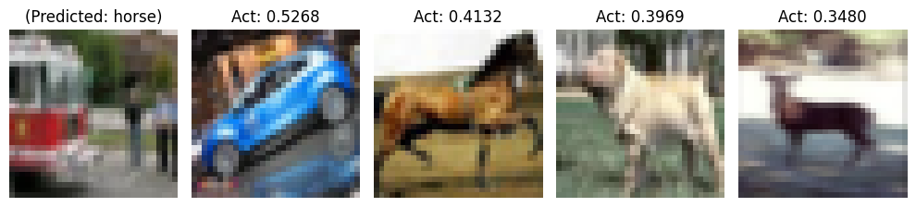

--- Query 8007 ---

True Class: truck

Predicted Class: horse

Top 3 Classes: horse, truck, deer

Top 3 Activations: 5.8647, 5.3902, 5.3288

Case 1:

Label: automobile

Activation: 0.5268

Case 2:

Label: horse

Activation: 0.4132

Case 3:

Label: dog

Activation: 0.3969

Case 4:

Label: deer

Activation: 0.3480

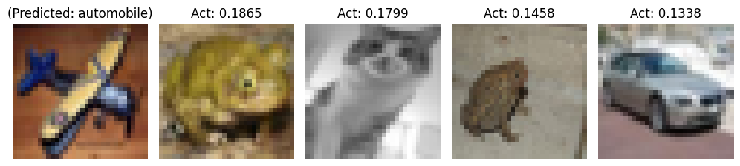

--- Query 8008 ---

True Class: airplane

Predicted Class: automobile

Top 3 Classes: automobile, frog, cat

Top 3 Activations: 1.9599, 1.8349, 1.5665

Case 1:

Label: frog

Activation: 0.1865

Case 2:

Label: cat

Activation: 0.1799

Case 3:

Label: frog

Activation: 0.1458

Case 4:

Label: automobile

Activation: 0.1338

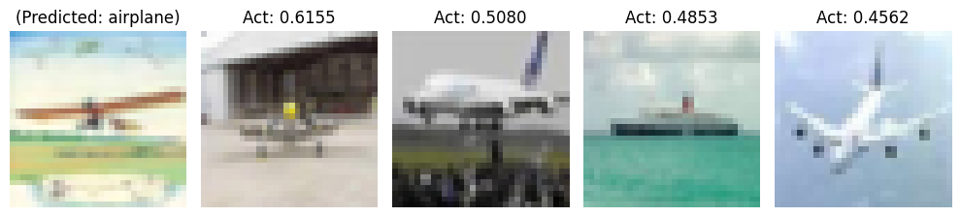

--- Query 8009 ---

True Class: airplane

Predicted Class: airplane

Top 3 Classes: airplane, ship, truck

Top 3 Activations: 8.7544, 6.8546, 4.8656

Case 1:

Label: airplane

Activation: 0.6155

Case 2:

Label: airplane

Activation: 0.5080

Case 3:

Label: ship

Activation: 0.4853

Case 4:

Label: airplane

Activation: 0.4562

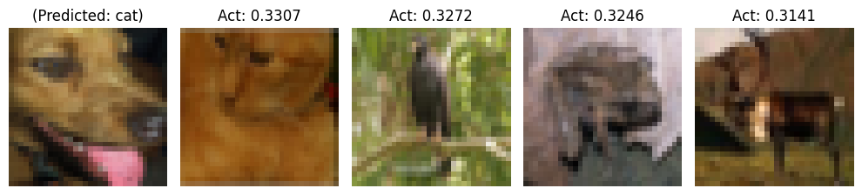

--- Query 8010 ---

True Class: dog

Predicted Class: cat

Top 3 Classes: cat, frog, dog

Top 3 Activations: 6.3987, 5.9114, 5.5661

Case 1:

Label: cat

Activation: 0.3307

Case 2:

Label: bird

Activation: 0.3272

Case 3:

Label: frog

Activation: 0.3246

Case 4:

Label: deer

Activation: 0.3141

Copy of results 1/16/2025



--- Query 1 ---

True Class: cat

Predicted Class: cat

Top 3 Classes: cat, dog, frog

Top 3 Activations: 5.7316, 4.8675, 4.4472

Case 1:

Label: deer

Activation: 0.4240

Case 2:

Label: automobile

Activation: 0.4060

Case 3:

Label: airplane

Activation: 0.3855

Case 4:

Label: frog

Activation: 0.3328



--- Query 2 ---

True Class: ship

Predicted Class: automobile

Top 3 Classes: automobile, airplane, ship

Top 3 Activations: 3.2945, 2.6865, 2.5443

Case 1:

Label: airplane

Activation: 0.2013

Case 2:

Label: automobile

Activation: 0.1807

Case 3:

Label: airplane

Activation: 0.1718

Case 4:

Label: automobile

Activation: 0.1682



--- Query 3 ---

True Class: ship

Predicted Class: airplane

Top 3 Classes: airplane, truck, ship

Top 3 Activations: 10.2598, 9.0202, 7.8461

Case 1:

Label: airplane

Activation: 0.4597

Case 2:

Label: deer

Activation: 0.4210

Case 3:

Label: automobile

Activation: 0.4043

Case 4:

Label: truck

Activation: 0.4033



--- Query 4 ---

True Class: airplane

Predicted Class: airplane

Top 3 Classes: airplane, ship, automobile

Top 3 Activations: 9.4300, 5.4787, 5.1161

Case 1:

Label: airplane

Activation: 0.4700

Case 2:

Label: frog

Activation: 0.4506

Case 3:

Label: airplane

Activation: 0.4276

Case 4:

Label: airplane

Activation: 0.4259

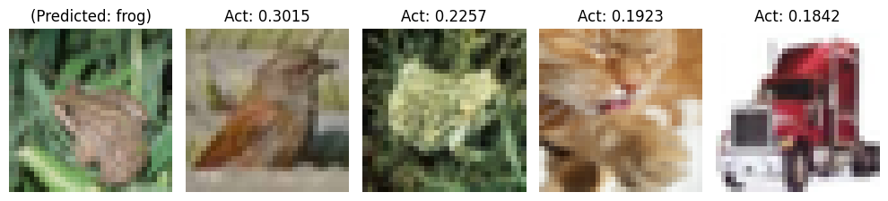

--- Query 5 ---

True Class: frog

Predicted Class: frog

Top 3 Classes: frog, cat, deer

Top 3 Activations: 3.8082, 3.6812, 3.1441

Case 1:

Label: bird

Activation: 0.3015

Case 2:

Label: frog

Activation: 0.2257

Case 3:

Label: cat

Activation: 0.1923

Case 4:

Label: truck

Activation: 0.1842



--- Query 6 ---

True Class: frog

Predicted Class: frog

Top 3 Classes: frog, deer, dog

Top 3 Activations: 7.8938, 4.3032, 3.9011

Case 1:

Label: frog

Activation: 0.3859

Case 2:

Label: ship

Activation: 0.3602

Case 3:

Label: dog

Activation: 0.3265

Case 4:

Label: frog

Activation: 0.3202



--- Query 7 ---

True Class: automobile

Predicted Class: automobile

Top 3 Classes: automobile, cat, dog

Top 3 Activations: 2.3816, 1.7513, 1.2627

Case 1:

Label: automobile

Activation: 0.2612

Case 2:

Label: automobile

Activation: 0.1503

Case 3:

Label: automobile

Activation: 0.1446

Case 4:

Label: cat

Activation: 0.1274



--- Query 8 ---

True Class: frog

Predicted Class: frog

Top 3 Classes: frog, deer, bird

Top 3 Activations: 6.8967, 6.5686, 6.4494

Case 1:

Label: deer

Activation: 0.5096

Case 2:

Label: frog

Activation: 0.4505

Case 3:

Label: bird

Activation: 0.3585

Case 4:

Label: bird

Activation: 0.3549



--- Query 9 ---

True Class: cat

Predicted Class: cat

Top 3 Classes: cat, dog, deer

Top 3 Activations: 10.1691, 9.4865, 9.1740

Case 1:

Label: horse

Activation: 0.5814

Case 2:

Label: deer

Activation: 0.5781

Case 3:

Label: deer

Activation: 0.5448

Case 4:

Label: cat

Activation: 0.4992



--- Query 10 ---

True Class: automobile

Predicted Class: automobile

Top 3 Classes: automobile, truck, ship

Top 3 Activations: 10.2318, 5.5759, 3.7436

Case 1:

Label: automobile

Activation: 0.6256

Case 2:

Label: automobile

Activation: 0.5097

Case 3:

Label: automobile

Activation: 0.4626

Case 4:

Label: automobile

Activation: 0.3962



--- Query 51 ---

True Class: truck

Predicted Class: truck

Top 3 Classes: truck, automobile, airplane

Top 3 Activations: 5.9380, 4.6051, 4.5238

Case 1:

Label: truck

Activation: 0.5884

Case 2:

Label: truck

Activation: 0.3604

Case 3:

Label: automobile

Activation: 0.3081

Case 4:

Label: truck

Activation: 0.3074



--- Query 52 ---

True Class: ship

Predicted Class: truck

Top 3 Classes: truck, ship, deer

Top 3 Activations: 6.2083, 6.0682, 5.6050

Case 1:

Label: airplane

Activation: 0.4507

Case 2:

Label: deer

Activation: 0.3574

Case 3:

Label: ship

Activation: 0.3446

Case 4:

Label: automobile

Activation: 0.3227



--- Query 53 ---

True Class: airplane

Predicted Class: bird

Top 3 Classes: bird, dog, frog

Top 3 Activations: 7.6789, 6.6253, 6.0948

Case 1:

Label: dog

Activation: 0.4767

Case 2:

Label: frog

Activation: 0.4569

Case 3:

Label: bird

Activation: 0.4541

Case 4:

Label: bird

Activation: 0.4366



--- Query 54 ---

True Class: cat

Predicted Class: bird

Top 3 Classes: bird, cat, frog

Top 3 Activations: 7.3834, 7.1461, 6.6513

Case 1:

Label: airplane

Activation: 0.5237

Case 2:

Label: dog

Activation: 0.4137

Case 3:

Label: dog

Activation: 0.4052

Case 4:

Label: frog

Activation: 0.3935



--- Query 55 ---

True Class: ship

Predicted Class: airplane

Top 3 Classes: airplane, ship, truck

Top 3 Activations: 8.3800, 7.0220, 3.2896

Case 1:

Label: airplane

Activation: 0.6984

Case 2:

Label: airplane

Activation: 0.5771

Case 3:

Label: ship

Activation: 0.5258

Case 4:

Label: ship

Activation: 0.4235



--- Query 56 ---

True Class: ship

Predicted Class: ship

Top 3 Classes: ship, airplane, deer

Top 3 Activations: 13.3723, 11.7269, 7.6291

Case 1:

Label: ship

Activation: 0.7835

Case 2:

Label: frog

Activation: 0.7674

Case 3:

Label: ship

Activation: 0.6564

Case 4:

Label: ship

Activation: 0.6062



--- Query 57 ---

True Class: horse

Predicted Class: cat

Top 3 Classes: cat, dog, horse

Top 3 Activations: 4.5570, 3.9317, 3.3979

Case 1:

Label: cat

Activation: 0.2605

Case 2:

Label: cat

Activation: 0.2480

Case 3:

Label: dog

Activation: 0.1957

Case 4:

Label: cat

Activation: 0.1935



--- Query 58 ---

True Class: horse

Predicted Class: frog

Top 3 Classes: frog, cat, deer

Top 3 Activations: 3.9910, 3.7820, 3.4395

Case 1:

Label: cat

Activation: 0.3192

Case 2:

Label: deer

Activation: 0.3047

Case 3:

Label: frog

Activation: 0.2640

Case 4:

Label: ship

Activation: 0.2191



--- Query 59 ---

True Class: deer

Predicted Class: dog

Top 3 Classes: dog, bird, cat

Top 3 Activations: 8.9500, 7.8850, 7.7148

Case 1:

Label: cat

Activation: 0.5123

Case 2:

Label: bird

Activation: 0.5075

Case 3:

Label: dog

Activation: 0.4784

Case 4:

Label: horse

Activation: 0.4385



--- Query 60 ---

True Class: frog

Predicted Class: dog

Top 3 Classes: dog, deer, cat

Top 3 Activations: 8.1056, 8.0862, 6.8440

Case 1:

Label: cat

Activation: 0.4595

Case 2:

Label: dog

Activation: 0.4593

Case 3:

Label: dog

Activation: 0.4521

Case 4:

Label: dog

Activation: 0.4506



--- Query 61 ---

True Class: horse

Predicted Class: horse

Top 3 Classes: horse, deer, dog

Top 3 Activations: 10.0312, 3.9441, 3.7847

Case 1:

Label: horse

Activation: 0.6234

Case 2:

Label: horse

Activation: 0.5300

Case 3:

Label: horse

Activation: 0.4598

Case 4:

Label: horse

Activation: 0.4598



--- Query 62 ---

True Class: cat

Predicted Class: dog

Top 3 Classes: dog, cat, horse

Top 3 Activations: 6.4403, 6.2795, 4.0347

Case 1:

Label: dog

Activation: 0.3562

Case 2:

Label: dog

Activation: 0.3475

Case 3:

Label: dog

Activation: 0.3328

Case 4:

Label: dog

Activation: 0.3325



--- Query 63 ---

True Class: frog

Predicted Class: frog

Top 3 Classes: frog, deer, cat

Top 3 Activations: 6.3194, 4.5602, 4.4429

Case 1:

Label: airplane

Activation: 0.3262

Case 2:

Label: ship

Activation: 0.3246

Case 3:

Label: frog

Activation: 0.3100

Case 4:

Label: deer

Activation: 0.2881



--- Query 64 ---

True Class: cat

Predicted Class: bird

Top 3 Classes: bird, airplane, cat

Top 3 Activations: 3.5913, 3.4943, 3.4673

Case 1:

Label: automobile

Activation: 0.2841

Case 2:

Label: cat

Activation: 0.2756

Case 3:

Label: cat

Activation: 0.2546

Case 4:

Label: cat

Activation: 0.2486



--- Query 65 ---

True Class: frog

Predicted Class: frog

Top 3 Classes: frog, cat, bird

Top 3 Activations: 8.9604, 5.9715, 5.2157

Case 1:

Label: frog

Activation: 0.6642

Case 2:

Label: bird

Activation: 0.3808

Case 3:

Label: bird

Activation: 0.3562

Case 4:

Label: bird

Activation: 0.3530



--- Query 66 ---

True Class: bird

Predicted Class: bird

Top 3 Classes: bird, frog, dog

Top 3 Activations: 5.9516, 4.4884, 3.2419

Case 1:

Label: bird

Activation: 0.5713

Case 2:

Label: bird

Activation: 0.3025

Case 3:

Label: dog

Activation: 0.2926

Case 4:

Label: bird

Activation: 0.2915



--- Query 67 ---

True Class: automobile

Predicted Class: automobile

Top 3 Classes: automobile, ship, airplane

Top 3 Activations: 5.8896, 5.2125, 4.9695

Case 1:

Label: airplane

Activation: 0.5044

Case 2:

Label: automobile

Activation: 0.3815

Case 3:

Label: automobile

Activation: 0.3306

Case 4:

Label: automobile

Activation: 0.3264



--- Query 68 ---

True Class: bird

Predicted Class: bird

Top 3 Classes: bird, dog, airplane

Top 3 Activations: 5.6681, 3.7223, 3.2185

Case 1:

Label: bird

Activation: 0.3834

Case 2:

Label: dog

Activation: 0.3487

Case 3:

Label: bird

Activation: 0.3145

Case 4:

Label: bird

Activation: 0.2899



--- Query 69 ---

True Class: cat

Predicted Class: cat

Top 3 Classes: cat, dog, horse

Top 3 Activations: 4.6344, 3.5724, 3.2913

Case 1:

Label: cat

Activation: 0.3147

Case 2:

Label: cat

Activation: 0.3139

Case 3:

Label: dog

Activation: 0.2742

Case 4:

Label: cat

Activation: 0.2635



--- Query 70 ---

True Class: horse

Predicted Class: horse

Top 3 Classes: horse, truck, automobile

Top 3 Activations: 7.0247, 6.9907, 6.6876

Case 1:

Label: deer

Activation: 0.4736

Case 2:

Label: automobile

Activation: 0.4399

Case 3:

Label: automobile

Activation: 0.4376

Case 4:

Label: horse

Activation: 0.4084



--- Query 71 ---

True Class: bird

Predicted Class: deer

Top 3 Classes: deer, cat, frog

Top 3 Activations: 11.4227, 10.6621, 10.5862

Case 1:

Label: dog

Activation: 0.7215

Case 2:

Label: dog

Activation: 0.6886

Case 3:

Label: bird

Activation: 0.6346

Case 4:

Label: deer

Activation: 0.6345



--- Query 72 ---

True Class: frog

Predicted Class: frog

Top 3 Classes: frog, dog, cat

Top 3 Activations: 8.3828, 7.0817, 6.2790

Case 1:

Label: deer

Activation: 0.5442

Case 2:

Label: cat

Activation: 0.5303

Case 3:

Label: dog

Activation: 0.4963

Case 4:

Label: frog

Activation: 0.4153



--- Query 73 ---

True Class: ship

Predicted Class: ship

Top 3 Classes: ship, dog, airplane

Top 3 Activations: 9.6095, 4.6164, 4.5441

Case 1:

Label: ship

Activation: 0.4804

Case 2:

Label: ship

Activation: 0.4228

Case 3:

Label: ship

Activation: 0.4214

Case 4:

Label: ship

Activation: 0.4125



--- Query 74 ---

True Class: ship

Predicted Class: ship

Top 3 Classes: ship, airplane, truck

Top 3 Activations: 10.2444, 5.9621, 3.7061

Case 1:

Label: truck

Activation: 0.6981

Case 2:

Label: ship

Activation: 0.5666

Case 3:

Label: ship

Activation: 0.5309

Case 4:

Label: ship

Activation: 0.5240



--- Query 75 ---

True Class: airplane

Predicted Class: frog

Top 3 Classes: frog, airplane, truck

Top 3 Activations: 5.5281, 4.8645, 3.8733

Case 1:

Label: airplane

Activation: 0.4422

Case 2:

Label: frog

Activation: 0.3957

Case 3:

Label: bird

Activation: 0.3509

Case 4:

Label: truck

Activation: 0.3355



--- Query 76 ---

True Class: bird

Predicted Class: bird

Top 3 Classes: bird, deer, dog

Top 3 Activations: 3.5611, 3.0171, 2.9320

Case 1:

Label: bird

Activation: 0.3341

Case 2:

Label: deer

Activation: 0.2940

Case 3:

Label: horse

Activation: 0.2743

Case 4:

Label: dog

Activation: 0.2623



--- Query 77 ---

True Class: truck

Predicted Class: airplane

Top 3 Classes: airplane, truck, horse

Top 3 Activations: 4.8102, 4.3545, 4.2695

Case 1:

Label: horse

Activation: 0.3240

Case 2:

Label: airplane

Activation: 0.3134

Case 3:

Label: airplane

Activation: 0.3068

Case 4:

Label: truck

Activation: 0.2657



--- Query 78 ---

True Class: cat

Predicted Class: cat

Top 3 Classes: cat, frog, dog

Top 3 Activations: 8.6298, 6.8949, 5.6481

Case 1:

Label: cat

Activation: 0.4948

Case 2:

Label: cat

Activation: 0.4153

Case 3:

Label: dog

Activation: 0.3933

Case 4:

Label: cat

Activation: 0.3812



--- Query 79 ---

True Class: cat

Predicted Class: horse

Top 3 Classes: horse, cat, dog

Top 3 Activations: 6.6129, 6.5011, 6.3697

Case 1:

Label: horse

Activation: 0.4319

Case 2:

Label: horse

Activation: 0.3684

Case 3:

Label: cat

Activation: 0.3554

Case 4:

Label: horse

Activation: 0.3080



--- Query 80 ---

True Class: ship

Predicted Class: ship

Top 3 Classes: ship, airplane, automobile

Top 3 Activations: 8.8367, 7.3511, 6.1070

Case 1:

Label: ship

Activation: 0.5631

Case 2:

Label: ship

Activation: 0.5237

Case 3:

Label: automobile

Activation: 0.5161

Case 4:

Label: ship

Activation: 0.4779



--- Query 81 ---

True Class: ship

Predicted Class: ship

Top 3 Classes: ship, airplane, automobile

Top 3 Activations: 13.9919, 8.1820, 6.6057

Case 1:

Label: ship

Activation: 0.6352

Case 2:

Label: airplane

Activation: 0.5906

Case 3:

Label: ship

Activation: 0.5765

Case 4:

Label: ship

Activation: 0.5764



--- Query 82 ---

True Class: automobile

Predicted Class: automobile

Top 3 Classes: automobile, truck, airplane

Top 3 Activations: 3.8651, 2.5772, 2.3594

Case 1:

Label: airplane

Activation: 0.3208

Case 2:

Label: truck

Activation: 0.2819

Case 3:

Label: airplane

Activation: 0.2098

Case 4:

Label: automobile

Activation: 0.2052



--- Query 83 ---

True Class: automobile

Predicted Class: automobile

Top 3 Classes: automobile, truck, airplane

Top 3 Activations: 7.2433, 3.4011, 3.0561

Case 1:

Label: automobile

Activation: 0.4737

Case 2:

Label: automobile

Activation: 0.4001

Case 3:

Label: automobile

Activation: 0.3892

Case 4:

Label: automobile

Activation: 0.3129



--- Query 84 ---

True Class: horse

Predicted Class: horse

Top 3 Classes: horse, cat, dog

Top 3 Activations: 10.5308, 8.6292, 8.3615

Case 1:

Label: dog

Activation: 0.6662

Case 2:

Label: cat

Activation: 0.5280

Case 3:

Label: horse

Activation: 0.5249

Case 4:

Label: horse

Activation: 0.4712



--- Query 85 ---

True Class: bird

Predicted Class: airplane

Top 3 Classes: airplane, bird, dog

Top 3 Activations: 13.9448, 13.4870, 9.5177

Case 1:

Label: bird

Activation: 0.7668

Case 2:

Label: airplane

Activation: 0.6186

Case 3:

Label: airplane

Activation: 0.6167

Case 4:

Label: bird

Activation: 0.6130



--- Query 86 ---

True Class: dog

Predicted Class: bird

Top 3 Classes: bird, deer, horse

Top 3 Activations: 6.6815, 5.9878, 5.7801

Case 1:

Label: bird

Activation: 0.4040

Case 2:

Label: dog

Activation: 0.3674

Case 3:

Label: frog

Activation: 0.3453

Case 4:

Label: deer

Activation: 0.3442



--- Query 87 ---

True Class: bird

Predicted Class: bird

Top 3 Classes: bird, deer, airplane

Top 3 Activations: 5.8515, 4.0132, 4.0063

Case 1:

Label: automobile

Activation: 0.3922

Case 2:

Label: bird

Activation: 0.3804

Case 3:

Label: bird

Activation: 0.3165

Case 4:

Label: bird

Activation: 0.3051



--- Query 88 ---

True Class: horse

Predicted Class: airplane

Top 3 Classes: airplane, ship, deer

Top 3 Activations: 9.4402, 8.8081, 7.2549

Case 1:

Label: airplane

Activation: 0.5835

Case 2:

Label: airplane

Activation: 0.5208

Case 3:

Label: automobile

Activation: 0.5062

Case 4:

Label: airplane

Activation: 0.4863



--- Query 89 ---

True Class: ship

Predicted Class: truck

Top 3 Classes: truck, ship, cat

Top 3 Activations: 7.9088, 6.4694, 3.7300

Case 1:

Label: truck

Activation: 0.6004

Case 2:

Label: truck

Activation: 0.5506

Case 3:

Label: truck

Activation: 0.3641

Case 4:

Label: truck

Activation: 0.3608



--- Query 90 ---

True Class: truck

Predicted Class: truck

Top 3 Classes: truck, automobile, airplane

Top 3 Activations: 6.6610, 4.2704, 2.7287

Case 1:

Label: truck

Activation: 0.3822

Case 2:

Label: truck

Activation: 0.3634

Case 3:

Label: automobile

Activation: 0.3062

Case 4:

Label: truck

Activation: 0.3027



--- Query 8001 ---

True Class: truck

Predicted Class: truck

Top 3 Classes: truck, automobile, airplane

Top 3 Activations: 10.9729, 4.6527, 3.7972

Case 1:

Label: truck

Activation: 0.5019

Case 2:

Label: truck

Activation: 0.4894

Case 3:

Label: automobile

Activation: 0.4847

Case 4:

Label: truck

Activation: 0.4805



--- Query 8002 ---

True Class: automobile

Predicted Class: automobile

Top 3 Classes: automobile, ship, truck

Top 3 Activations: 6.3626, 5.9754, 4.9910

Case 1:

Label: ship

Activation: 0.4798

Case 2:

Label: automobile

Activation: 0.4733

Case 3:

Label: ship

Activation: 0.3856

Case 4:

Label: automobile

Activation: 0.3516



--- Query 8003 ---

True Class: frog

Predicted Class: frog

Top 3 Classes: frog, automobile, cat

Top 3 Activations: 2.7930, 1.9514, 1.7057

Case 1:

Label: frog

Activation: 0.2189

Case 2:

Label: frog

Activation: 0.1872

Case 3:

Label: automobile

Activation: 0.1692

Case 4:

Label: automobile

Activation: 0.1627



--- Query 8004 ---

True Class: deer

Predicted Class: bird

Top 3 Classes: bird, frog, deer

Top 3 Activations: 3.8879, 3.4674, 3.4597

Case 1:

Label: frog

Activation: 0.2469

Case 2:

Label: cat

Activation: 0.2294

Case 3:

Label: bird

Activation: 0.2226

Case 4:

Label: cat

Activation: 0.2209



--- Query 8005 ---

True Class: horse

Predicted Class: horse

Top 3 Classes: horse, deer, bird

Top 3 Activations: 5.1531, 4.4324, 3.5669

Case 1:

Label: frog

Activation: 0.3337

Case 2:

Label: deer

Activation: 0.3104

Case 3:

Label: cat

Activation: 0.2905

Case 4:

Label: deer

Activation: 0.2664



--- Query 8006 ---

True Class: automobile

Predicted Class: automobile

Top 3 Classes: automobile, truck, airplane

Top 3 Activations: 8.1482, 5.1552, 4.2721

Case 1:

Label: truck

Activation: 0.3999

Case 2:

Label: automobile

Activation: 0.3527

Case 3:

Label: automobile

Activation: 0.3490

Case 4:

Label: automobile

Activation: 0.3461



--- Query 8007 ---

True Class: truck

Predicted Class: horse

Top 3 Classes: horse, truck, deer

Top 3 Activations: 5.8647, 5.3902, 5.3288

Case 1:

Label: automobile

Activation: 0.5268

Case 2:

Label: horse

Activation: 0.4132

Case 3:

Label: dog

Activation: 0.3969

Case 4:

Label: deer

Activation: 0.3480



--- Query 8008 ---

True Class: airplane

Predicted Class: automobile

Top 3 Classes: automobile, frog, cat

Top 3 Activations: 1.9599, 1.8349, 1.5665

Case 1:

Label: frog

Activation: 0.1865

Case 2:

Label: cat

Activation: 0.1799

Case 3:

Label: frog

Activation: 0.1458

Case 4:

Label: automobile

Activation: 0.1338



--- Query 8009 ---

True Class: airplane

Predicted Class: airplane

Top 3 Classes: airplane, ship, truck

Top 3 Activations: 8.7544, 6.8546, 4.8656

Case 1:

Label: airplane

Activation: 0.6155

Case 2:

Label: airplane

Activation: 0.5080

Case 3:

Label: ship

Activation: 0.4853

Case 4:

Label: airplane

Activation: 0.4562



--- Query 8010 ---

True Class: dog

Predicted Class: cat

Top 3 Classes: cat, frog, dog

Top 3 Activations: 6.3987, 5.9114, 5.5661

Case 1:

Label: cat

Activation: 0.3307

Case 2:

Label: bird

Activation: 0.3272

Case 3:

Label: frog

Activation: 0.3246

Case 4:

Label: deer

Activation: 0.3141